Task 2
Query 1 — Rank products by total revenue

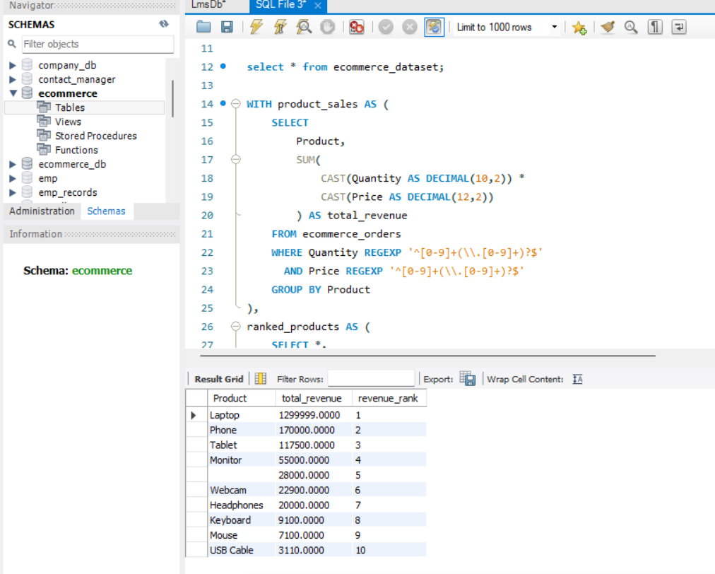
WITH product_sales AS (
SELECT
Product,
SUM(
CAST(Quantity AS DECIMAL(10,2)) *
CAST(Price AS DECIMAL(12,2))
) AS total_revenue
FROM ecommerce_orders
WHERE Quantity REGEXP '^[0-9]+(\\.[0-9]+)?$'
AND Price REGEXP '^[0-9]+(\\.[0-9]+)?$'
GROUP BY Product
),
ranked_products AS (
SELECT *,
DENSE_RANK() OVER (
ORDER BY total_revenue DESC
) AS revenue_rank
FROM product_sales
)
SELECT *
FROM ranked_products
ORDER BY revenue_rank;

Query 2 — Find duplicate order IDs
SELECT
Order_ID,
COUNT(*) AS occurrence_count,
GROUP_CONCAT(Product) AS products
FROM ecommerce_orders
GROUP BY Order_ID
HAVING COUNT(*) > 1
ORDER BY occurrence_count DESC;
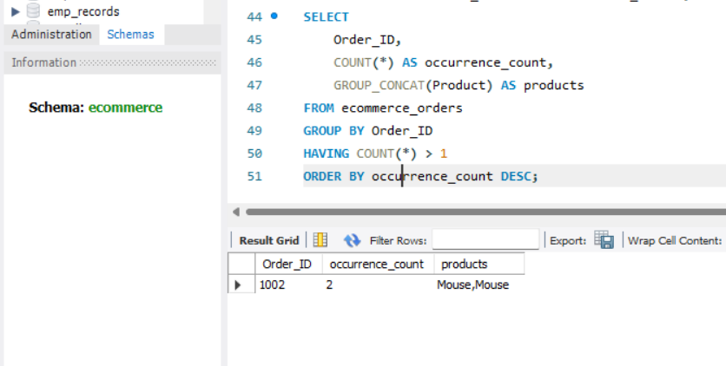

Query 3 — Calculate monthly revenue
WITH cleaned_orders AS (
SELECT
STR_TO_DATE(Order_Date, '%Y-%m-%d') AS order_date,
CAST(Quantity AS DECIMAL(10,2)) AS quantity,
CAST(Price AS DECIMAL(12,2)) AS price,
CAST(Discount AS DECIMAL(5,2)) AS discount
FROM ecommerce_orders
WHERE Order_Date REGEXP '^[0-9]{4}-[0-9]{2}-[0-9]{2}$'
AND Quantity REGEXP '^[0-9]+(\\.[0-9]+)?$'
AND Price REGEXP '^[0-9]+(\\.[0-9]+)?$'
)
SELECT
DATE_FORMAT(order_date, '%Y-%m') AS sales_month,
ROUND(SUM(
quantity * price *
(1 - COALESCE(discount, 0) / 100)
), 2) AS monthly_revenue
FROM cleaned_orders
WHERE order_date IS NOT NULL
GROUP BY DATE_FORMAT(order_date, '%Y-%m')
ORDER BY sales_month;
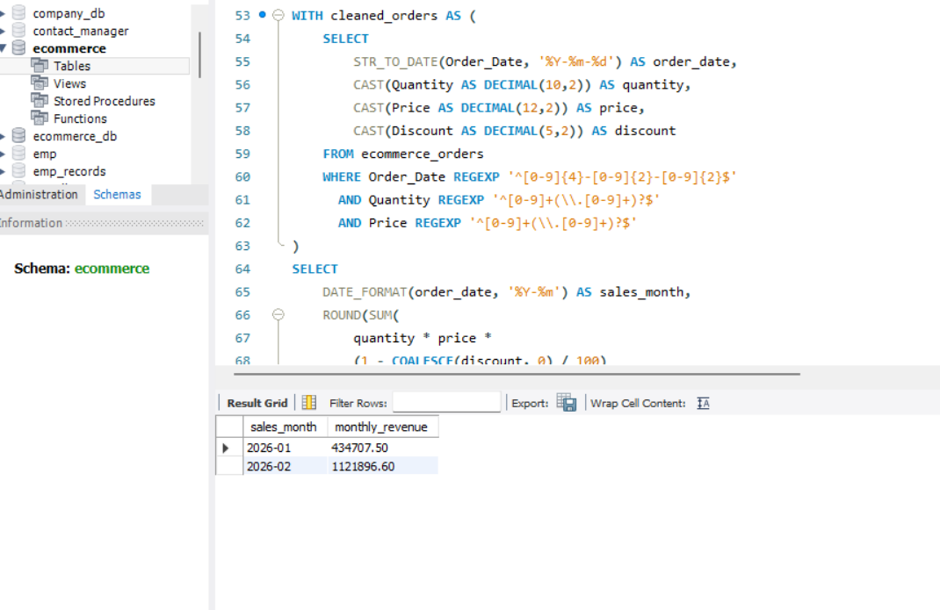

Query 4 — Identify high-value customers
SELECT
Customer,
COUNT(*) AS order_rows,
ROUND(SUM(
CAST(Quantity AS DECIMAL(10,2)) *
CAST(Price AS DECIMAL(12,2))
), 2) AS total_spend
FROM ecommerce_orders
WHERE Customer IS NOT NULL
AND Customer <> ''
AND Quantity REGEXP '^[0-9]+(\\.[0-9]+)?$'
AND Price REGEXP '^[0-9]+(\\.[0-9]+)?$'
GROUP BY Customer
HAVING total_spend > 20000
ORDER BY total_spend DESC;
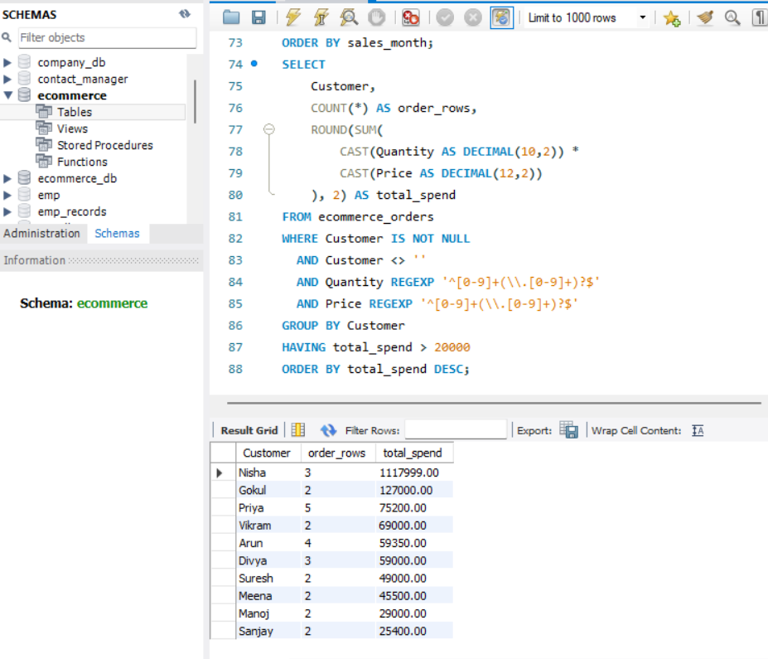
Query 5 — Find products priced above the average
WITH valid_prices AS (
SELECT
Product,
CAST(Price AS DECIMAL(12,2)) AS price
FROM ecommerce_orders
WHERE Price REGEXP '^[0-9]+(\\.[0-9]+)?$'
),
average_price AS (
SELECT AVG(price) AS avg_price
FROM valid_prices
)
SELECT
Product,
price,
ROUND(avg_price, 2) AS overall_average
FROM valid_prices
CROSS JOIN average_price
WHERE price > avg_price
ORDER BY price DESC;
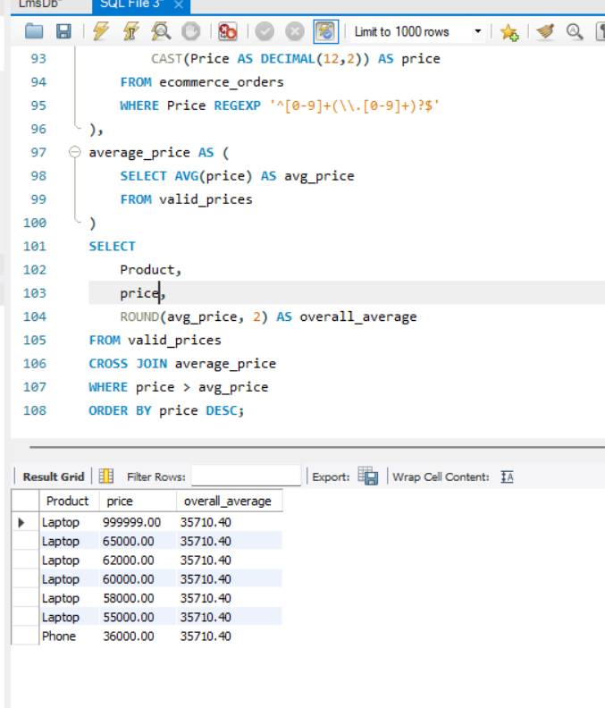
Query 6 — Detect missing and invalid data
SELECT
SUM(Customer IS NULL OR TRIM(Customer) = '') AS missing_customer,
SUM(Product IS NULL OR TRIM(Product) = '') AS missing_product,
SUM(Quantity IS NULL OR TRIM(Quantity) = '') AS missing_quantity,
SUM(Price IS NULL OR TRIM(Price) = '') AS missing_price,
SUM(Order_Date IS NULL OR TRIM(Order_Date) = '') AS missing_date,
SUM(Payment_Method IS NULL OR TRIM(Payment_Method) = '') AS missing_payment
FROM ecommerce_orders;

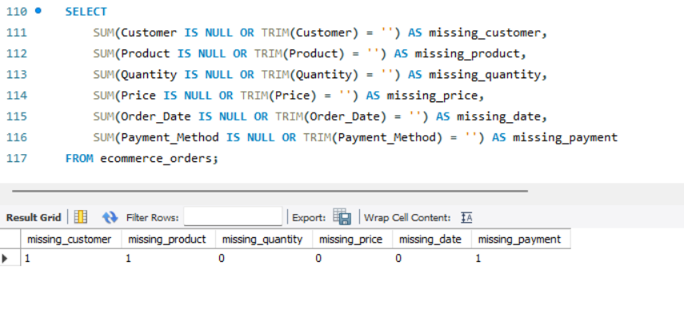

Query 7 — Compare payment methods by revenue
SELECT
Payment_Method,
COUNT(*) AS transaction_rows,
ROUND(SUM(
CAST(Quantity AS DECIMAL(10,2)) *
CAST(Price AS DECIMAL(12,2))
), 2) AS gross_revenue,
ROUND(
100.0 * SUM(
CAST(Quantity AS DECIMAL(10,2)) *
CAST(Price AS DECIMAL(12,2))
) / SUM(SUM(
CAST(Quantity AS DECIMAL(10,2)) *
CAST(Price AS DECIMAL(12,2))
)) OVER (),
2
) AS revenue_percentage
FROM ecommerce_orders
WHERE Payment_Method IS NOT NULL
AND Quantity REGEXP '^[0-9]+(\\.[0-9]+)?$'
AND Price REGEXP '^[0-9]+(\\.[0-9]+)?$'
GROUP BY Payment_Method
ORDER BY gross_revenue DESC;

